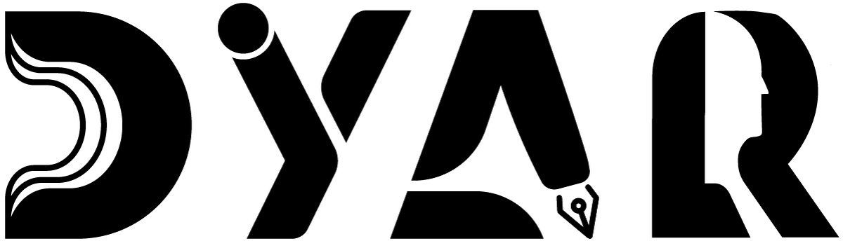
An NDIS Service Provider
RESOURCES HUB · EMP FAQ
Emergency Management — FAQ
Answers to common questions about fires, lockdowns, bushfires, power outages, illness, missed visits, lockdowns, and earthquakes.
Aligned to NDIS Practice Standards · NDIS Code of Conduct · NDIS Act 2013

Version 2 · 12 May 2026
DYAR Pty Ltd
NDIS Provider No. pending (Application 4-LRFP0J8) · ABN 68 695 255 504
Unit 1, 136 Main Street, Osborne Park WA 6017 · PO Box 8052, East Subiaco WA 6008
0470 540 306 · hello@dyar.com.au · Whadjuk Country

EMP Frequently Asked Questions
Answers to common questions about emergencies
Q: What do I do if there is a fire at the DYAR office?
A: Go outside immediately. Walk — don't run. Meet at the footpath on Main Street outside La Villa Centro. Wait for DYAR to count everyone. Do NOT go back inside.
Q: What if there is a fire at my home?
A: Tell everyone to GET OUT. Close doors behind you if you can. Go to your meeting place (usually the letterbox or driveway). Call 000. Do NOT go back inside.
Q: What if I cannot leave the building by myself?
A: Your PEEP (Personal Emergency Evacuation Plan) tells DYAR exactly how to help you. Your worker will be with you. You will be safe.
Q: Who do I call in an emergency?
A: ALWAYS call 000 first if there is real danger. Then call DYAR: Mehdi on 0470 540 306. We are available day and night for urgent things.
Q: What if there is a bushfire warning?
A: Check the WA Emergency website at emergency.wa.gov.au. If the danger is HIGH or higher — leave early. DYAR will call you to make sure you are safe.
Q: What if the power goes out?
A: Use a torch — NOT candles. Call DYAR if you have equipment that needs power (oxygen, fridge for medication, hoist).
Q: What if I'm sick — should I cancel?
A: Tell DYAR straight away. Call 0470 540 306. You will NOT be in trouble. DYAR will reschedule and check on you.
Q: What if my worker doesn't turn up?
A: Call Mehdi: 0470 540 306. We always have backup workers available.
Q: What if there is a lockdown at the building?
A: Stay inside. Lock external doors. Move to inner safe room. Wait for the all-clear from Service Manager or police.
Q: What if I need help in an earthquake?
A: DROP - COVER - HOLD. Drop to the ground, get under a sturdy table or desk, hold on. Stay clear of windows + heavy furniture.
Still have questions?
Phone: 0470 540 306
Email: hello@dyar.com.au
We answer every question without judgement.
___________________________________________
DYAR Pty Ltd · ABN 68 695 255 504 · Unit 1, 136 Main Street, Osborne Park WA 6017 · 0470 540 306 · hello@dyar.com.au · dyar.com.au · Whadjuk Country · V1 19 May 2026

